# Template for Project Report WDD

## Group: ____O____

Team member (id and name, Github link):

23524103, Christian Joseph, [Github](https://github.com/ChristianJ123ABC)

Team member (id and name, Github link):

23448774, Antoine Foudy, [Github](https://github.com/AntoineFoudy)

Team member (id and name, Github link):

23428404, Oisin Clare,

## Links:

Deployed: https://main.d1y5p5m0kvgkwc.amplifyapp.com/

If video report, video link: ________

# **For those doing the written report:**

## Screen shots of Wireframes:

**Gallery**

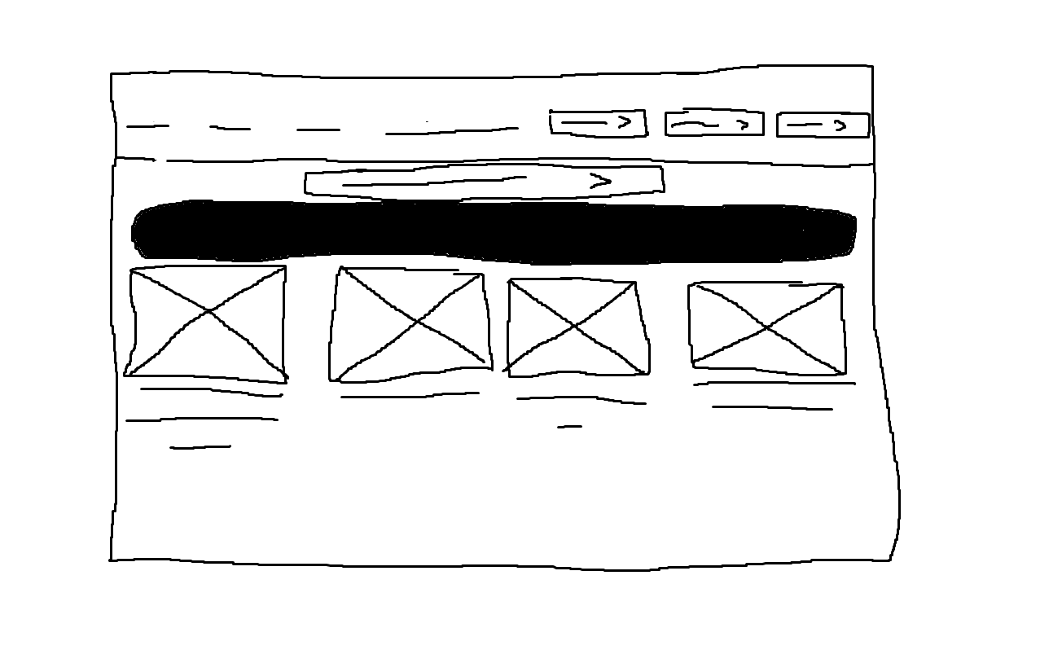

**Forms**

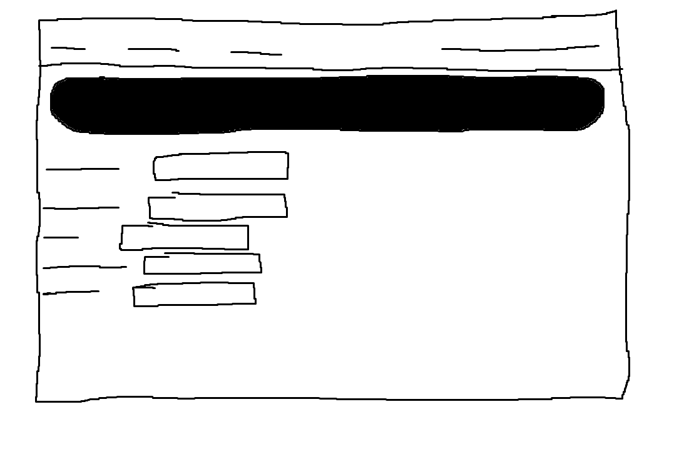

**Minigame home screen**

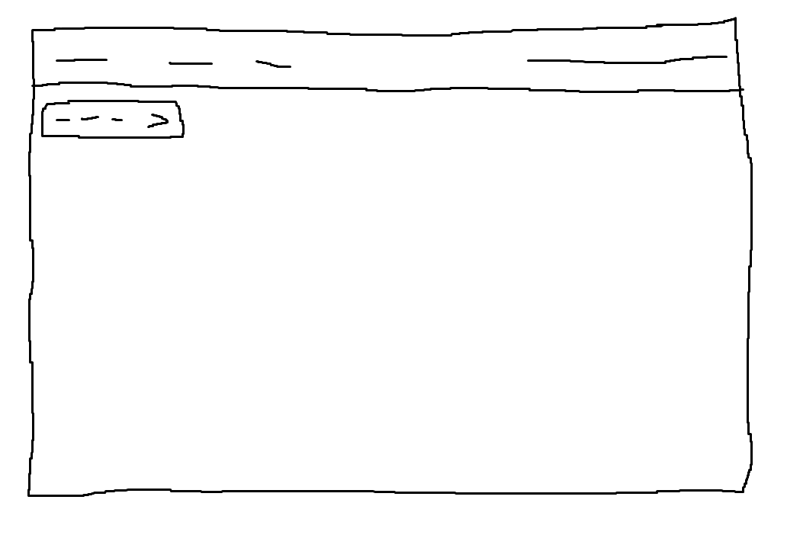

**Minigame game over screen**

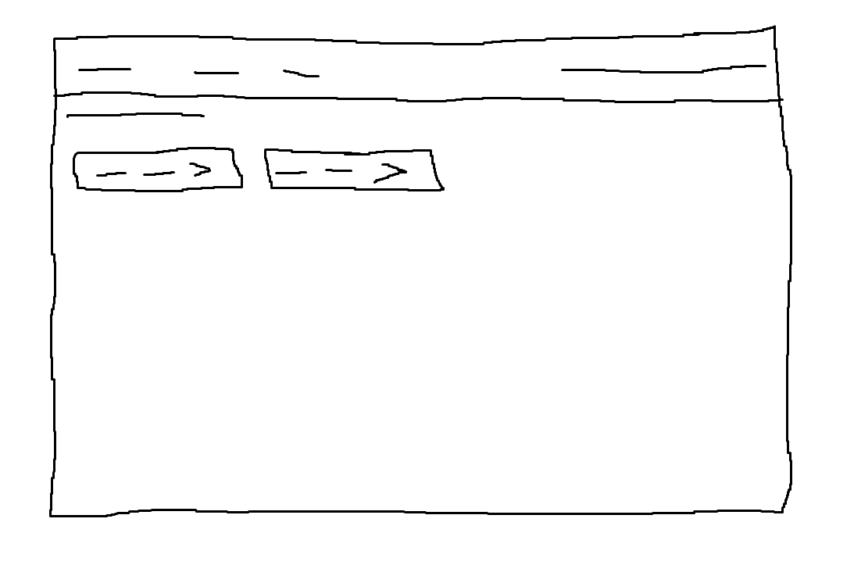

## Screen shot of sitemap:

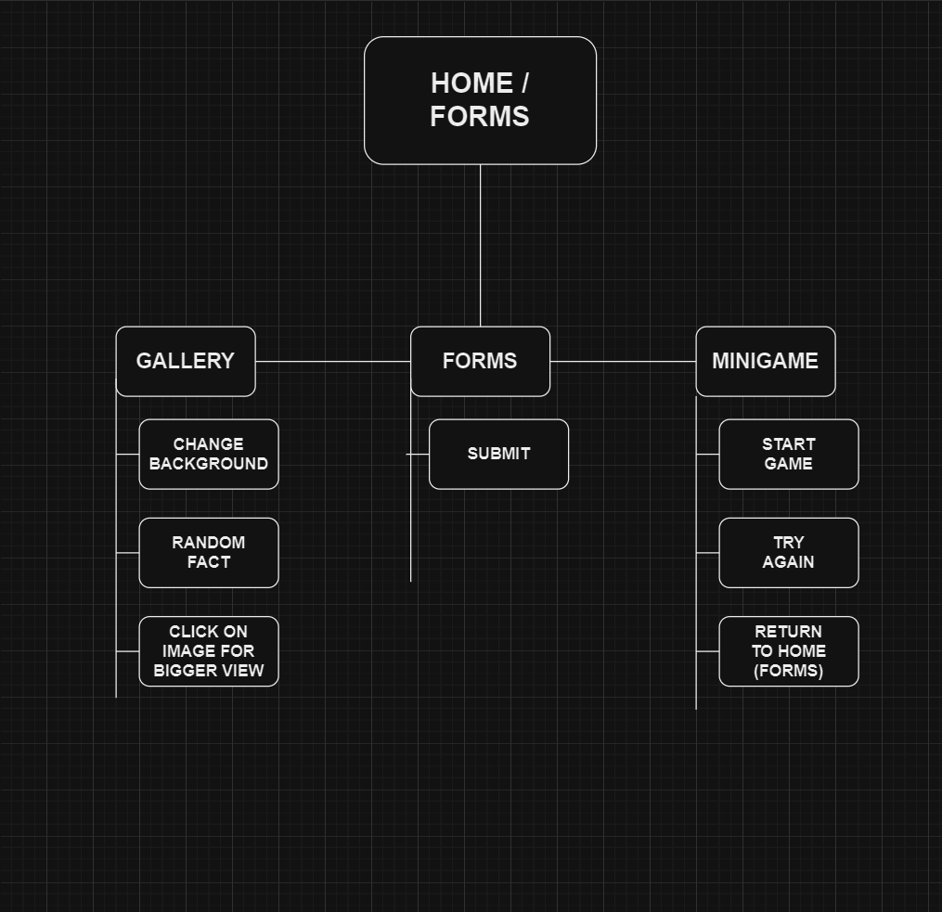

## Screen shot of Mood board:

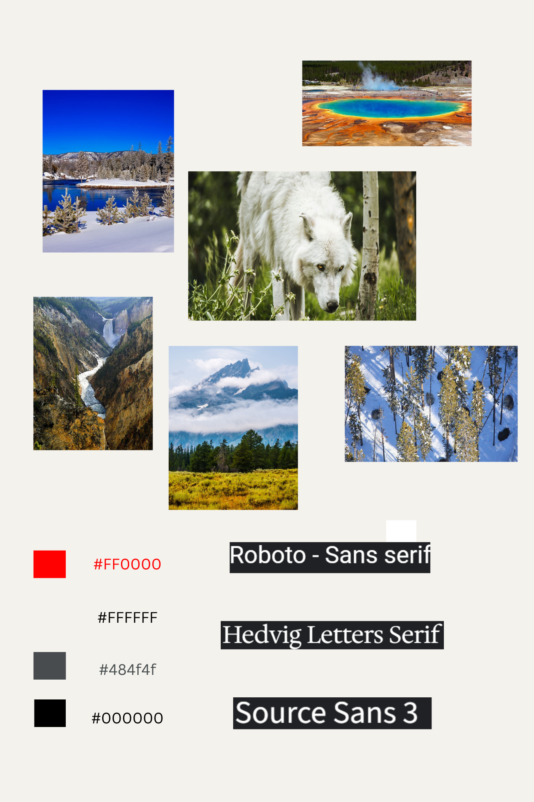

## Coding done by team member 1:

**HTML**

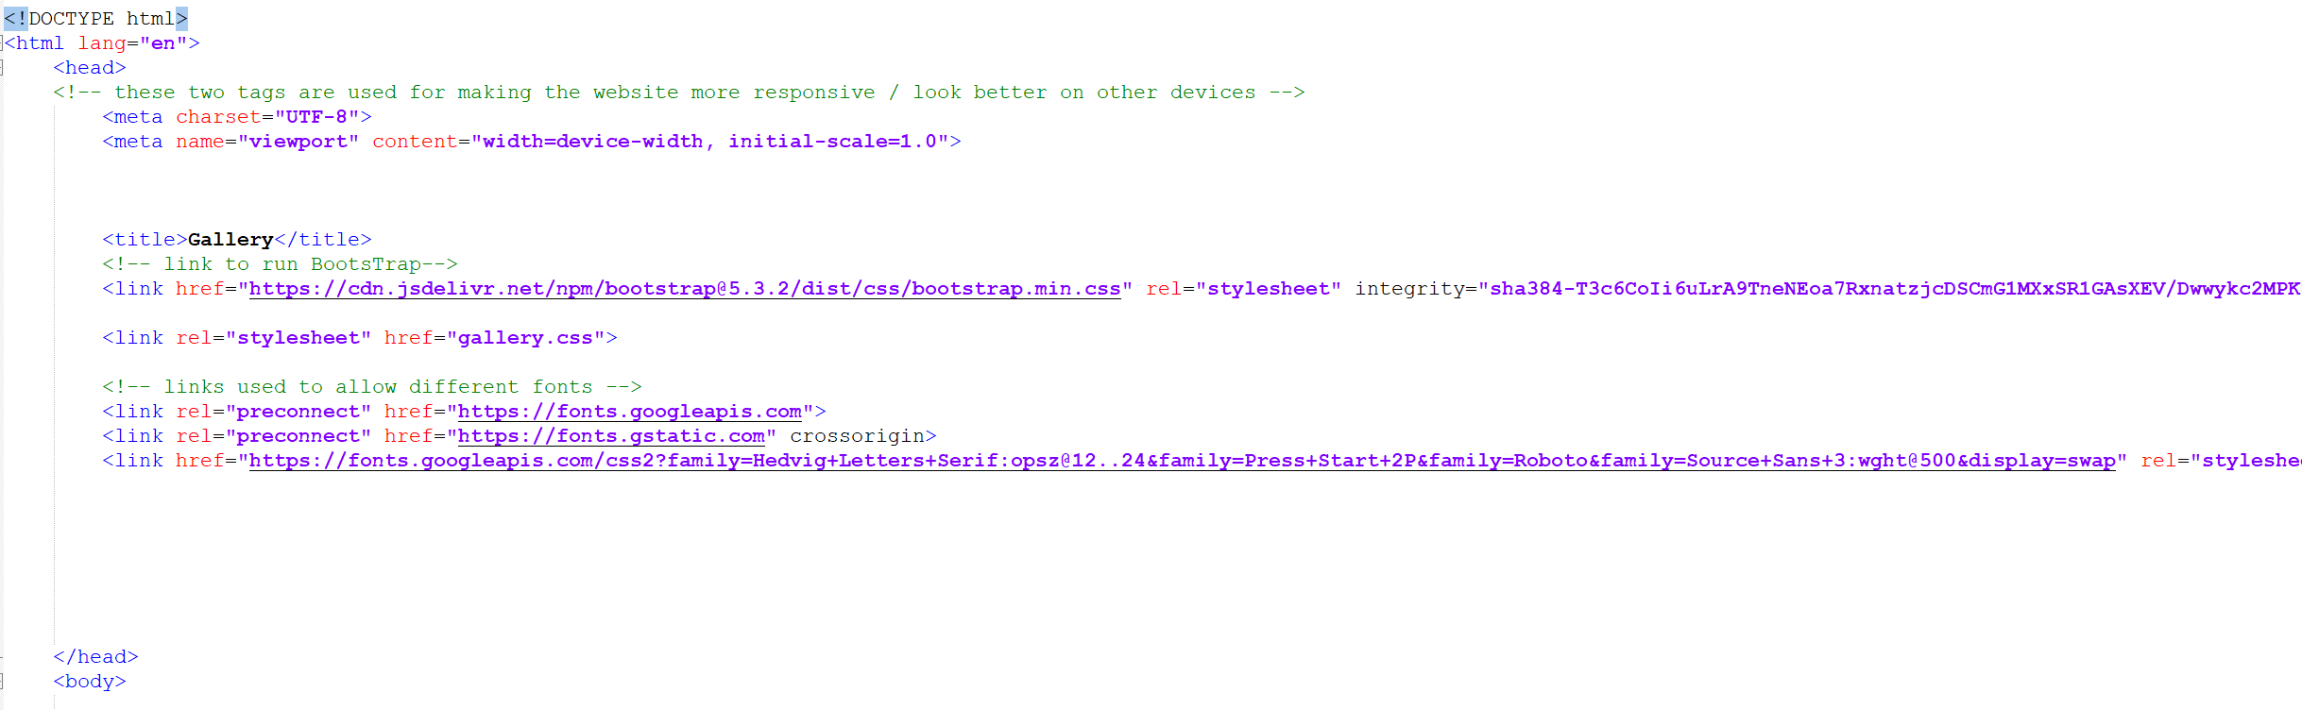

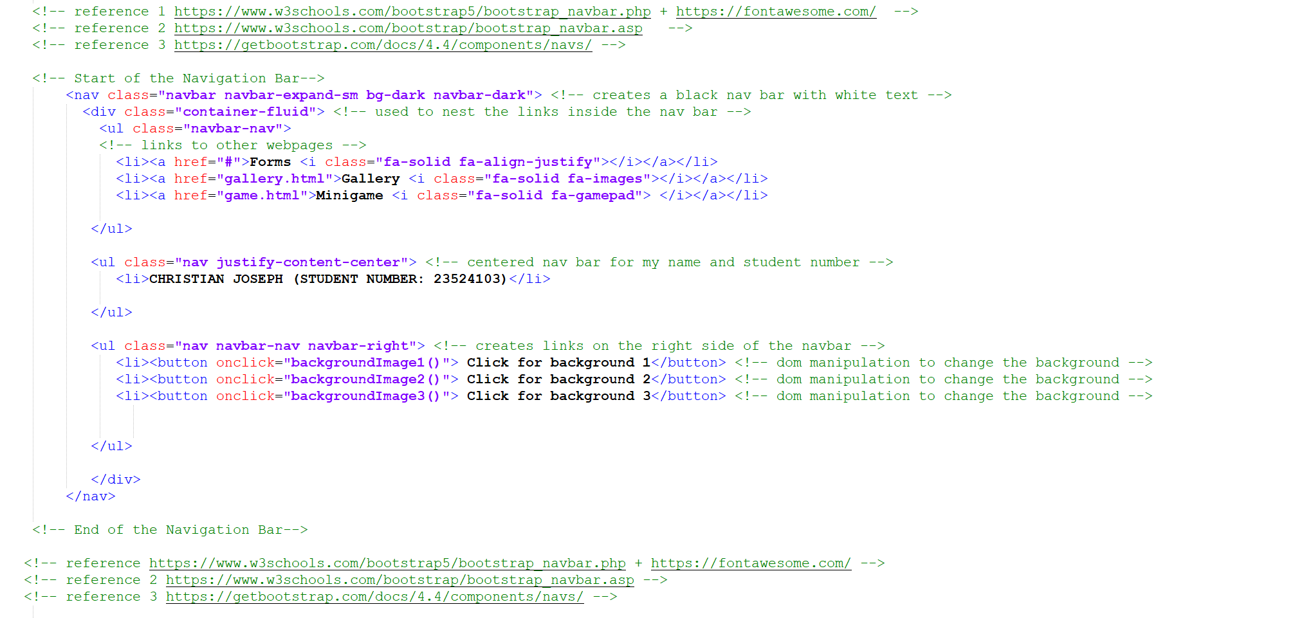





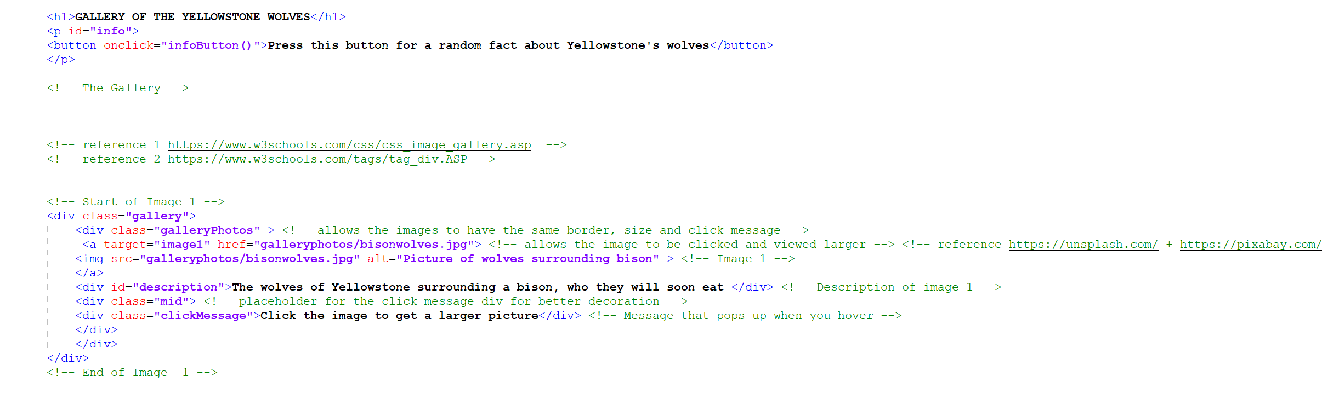

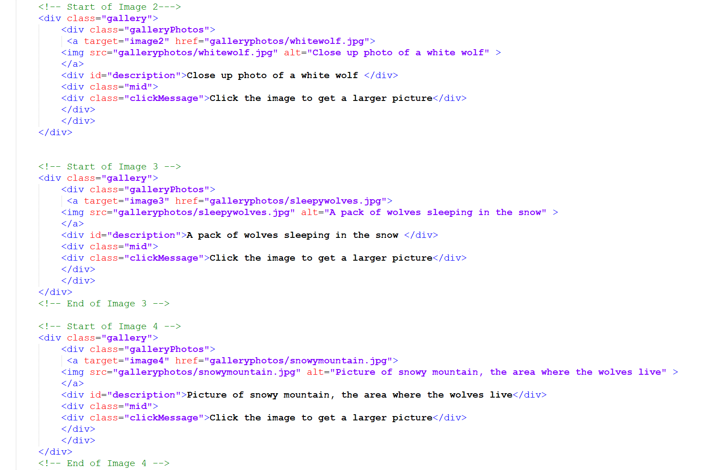

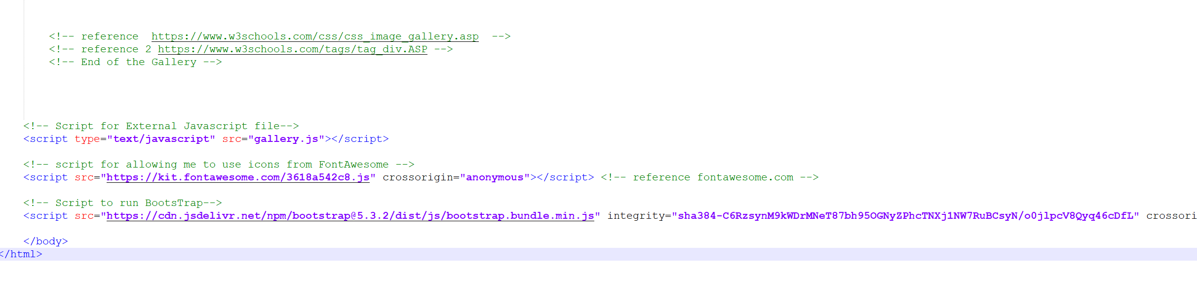

**CSS:**

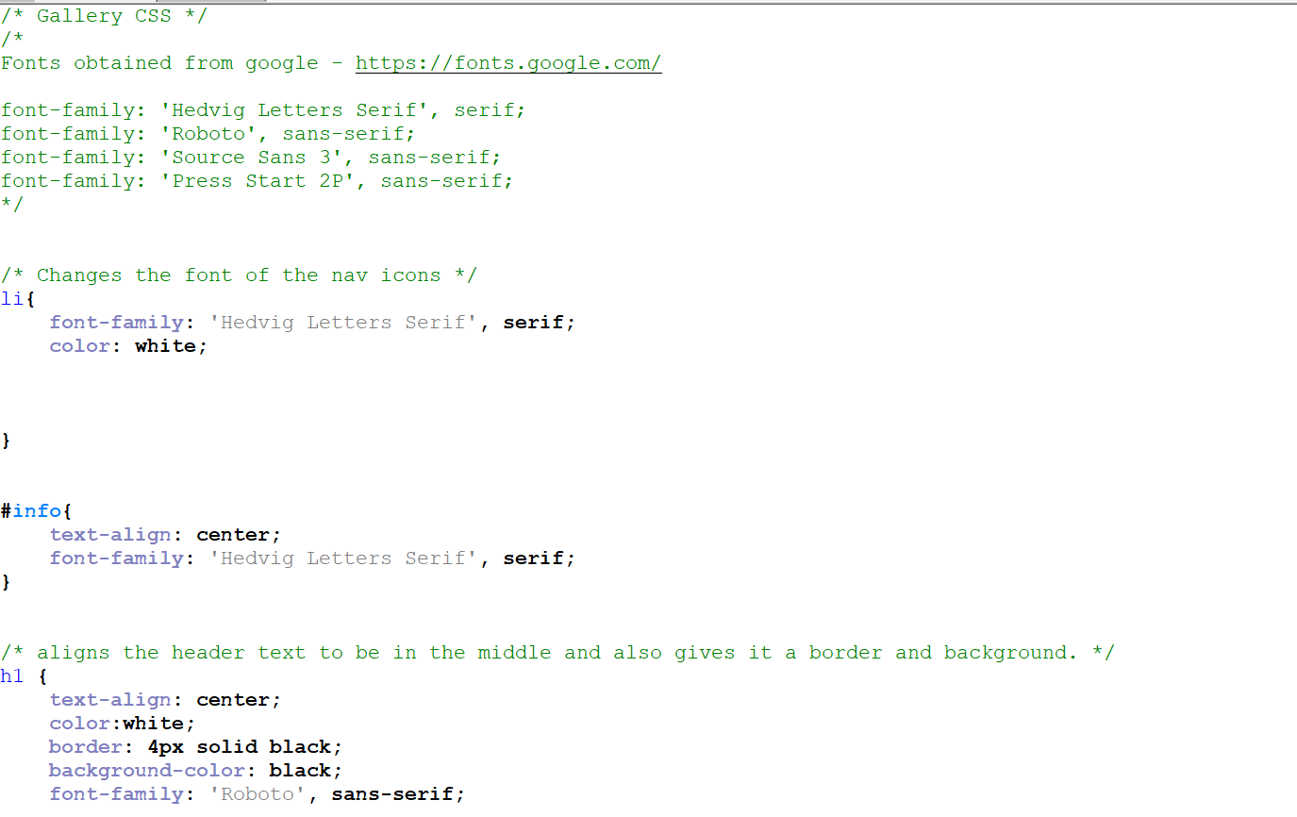

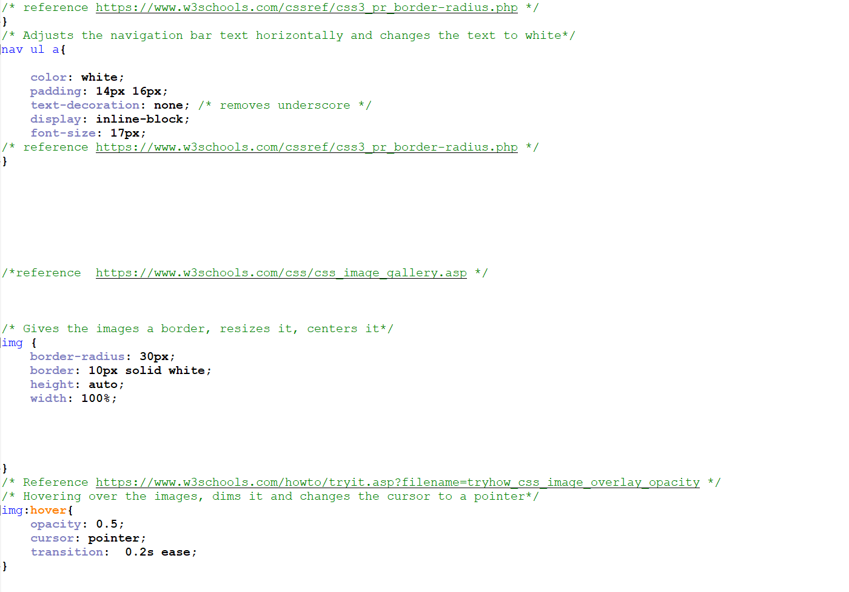

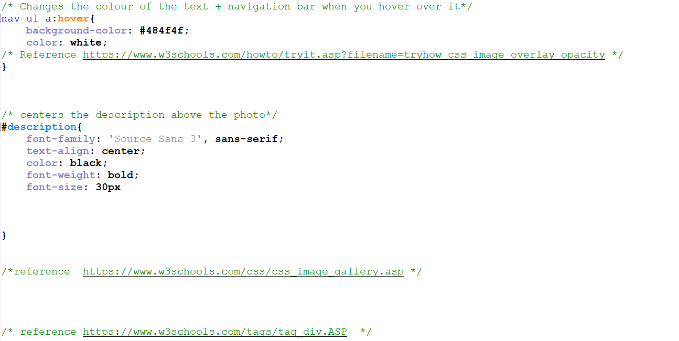

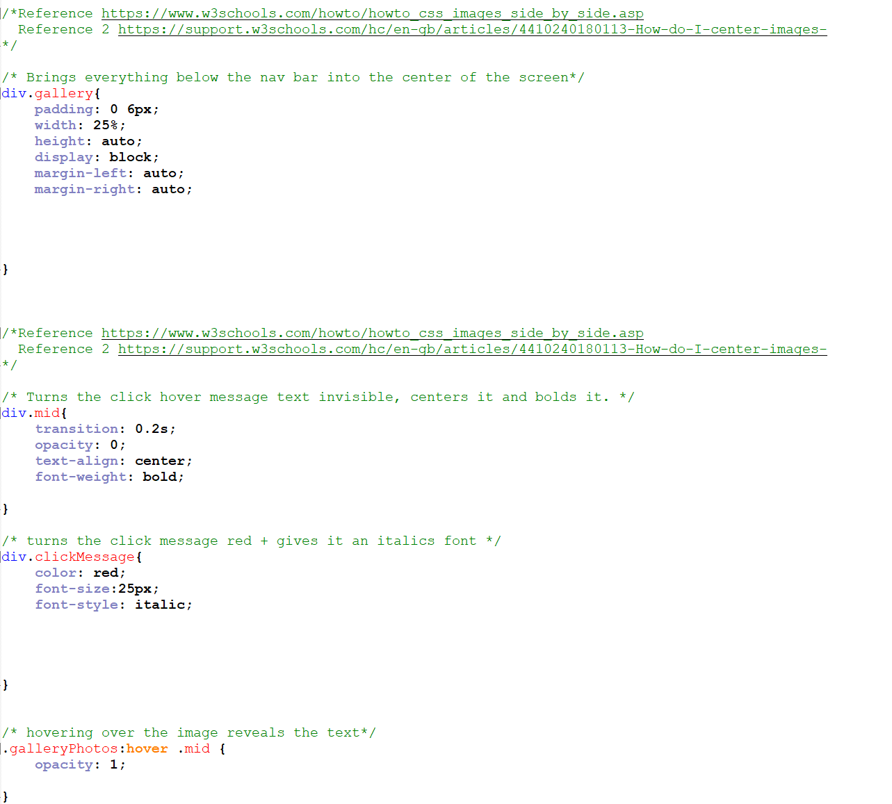

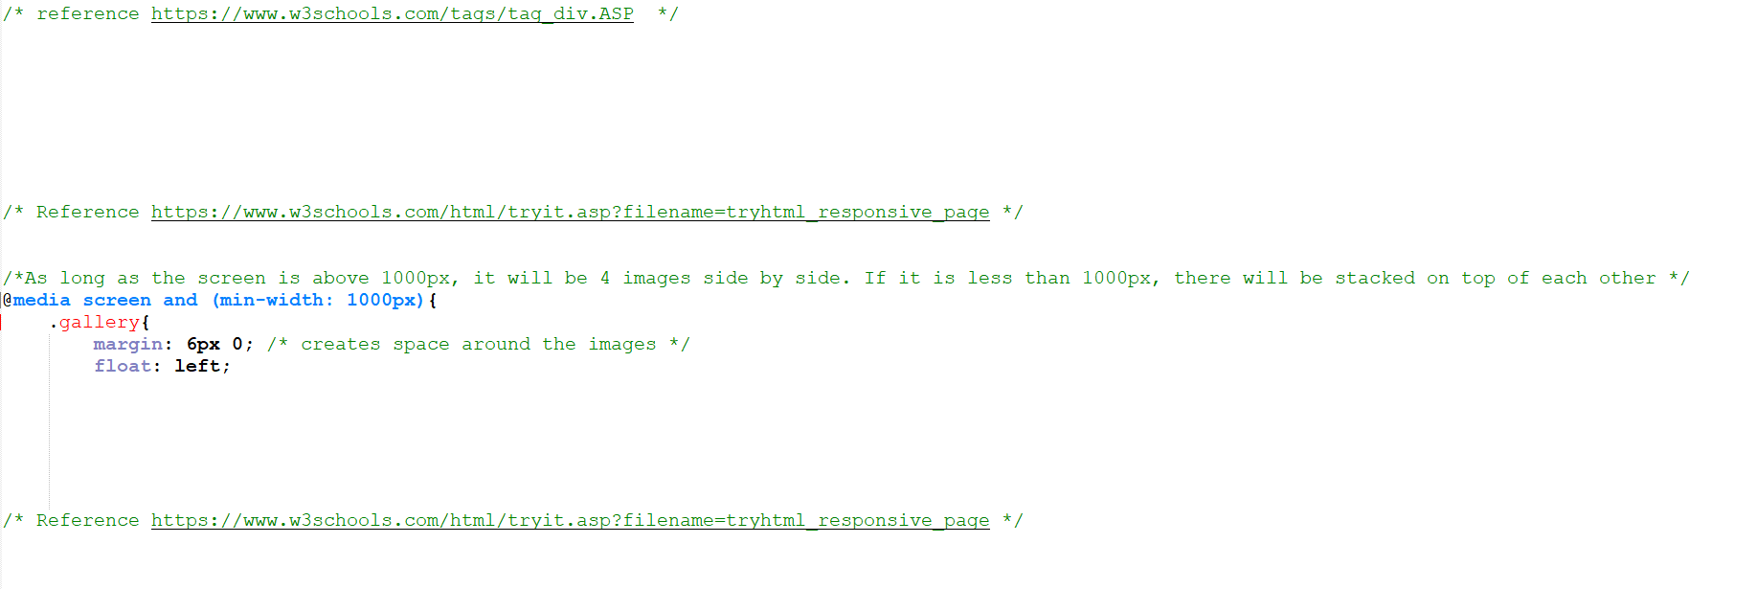

**JAVASCRIPT:**

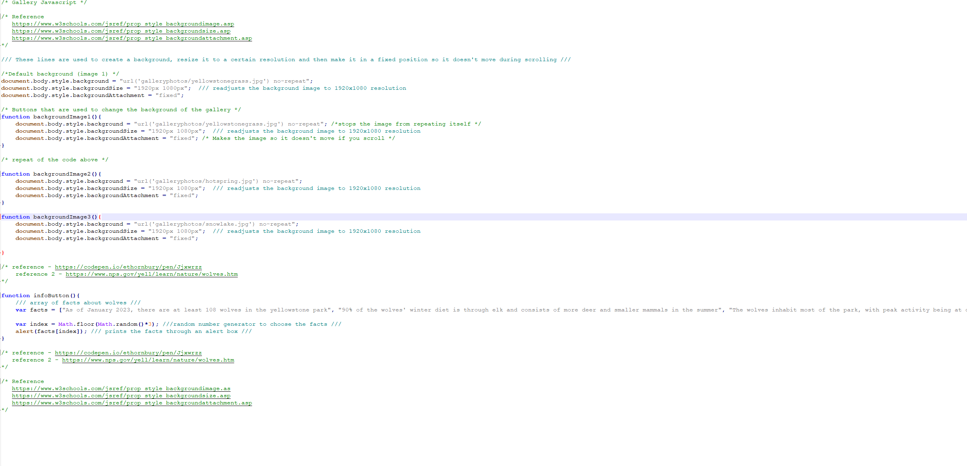

## Coding done by team member 2:

**HTML**

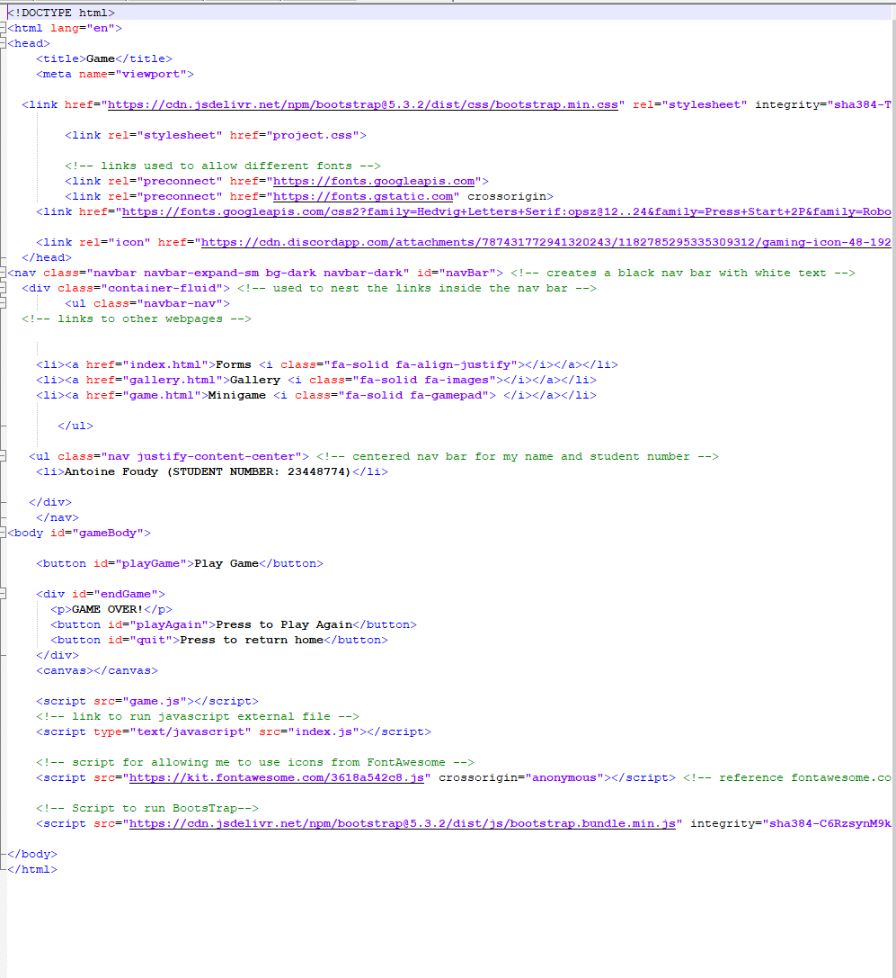

**JAVASCRIPT**

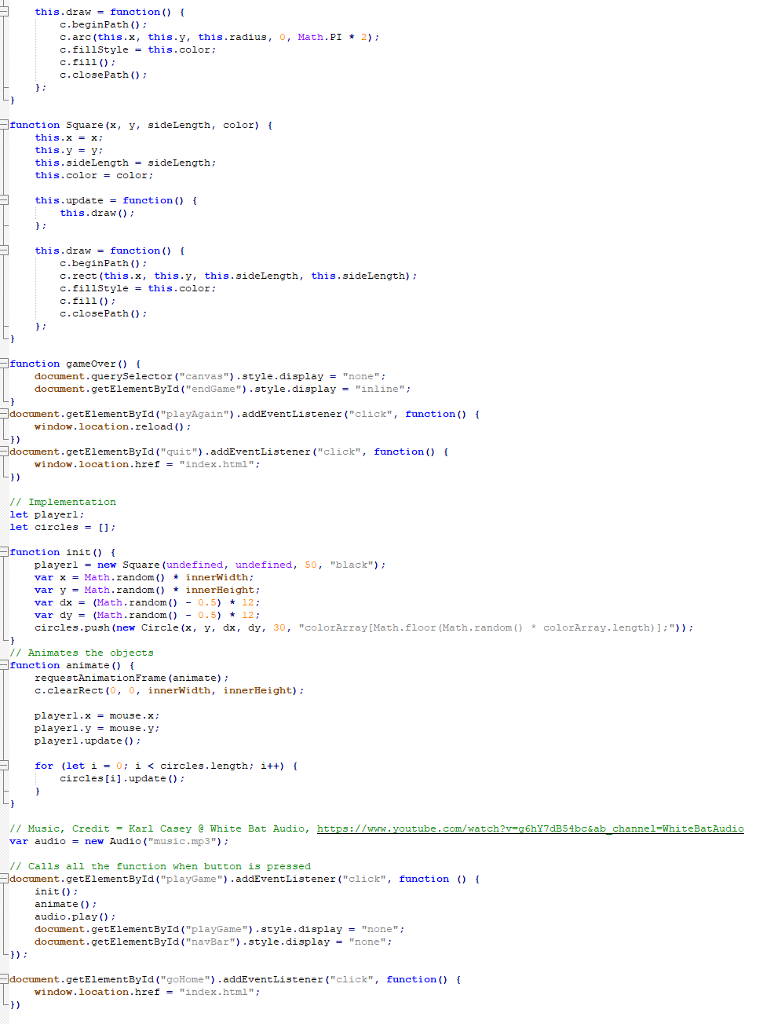

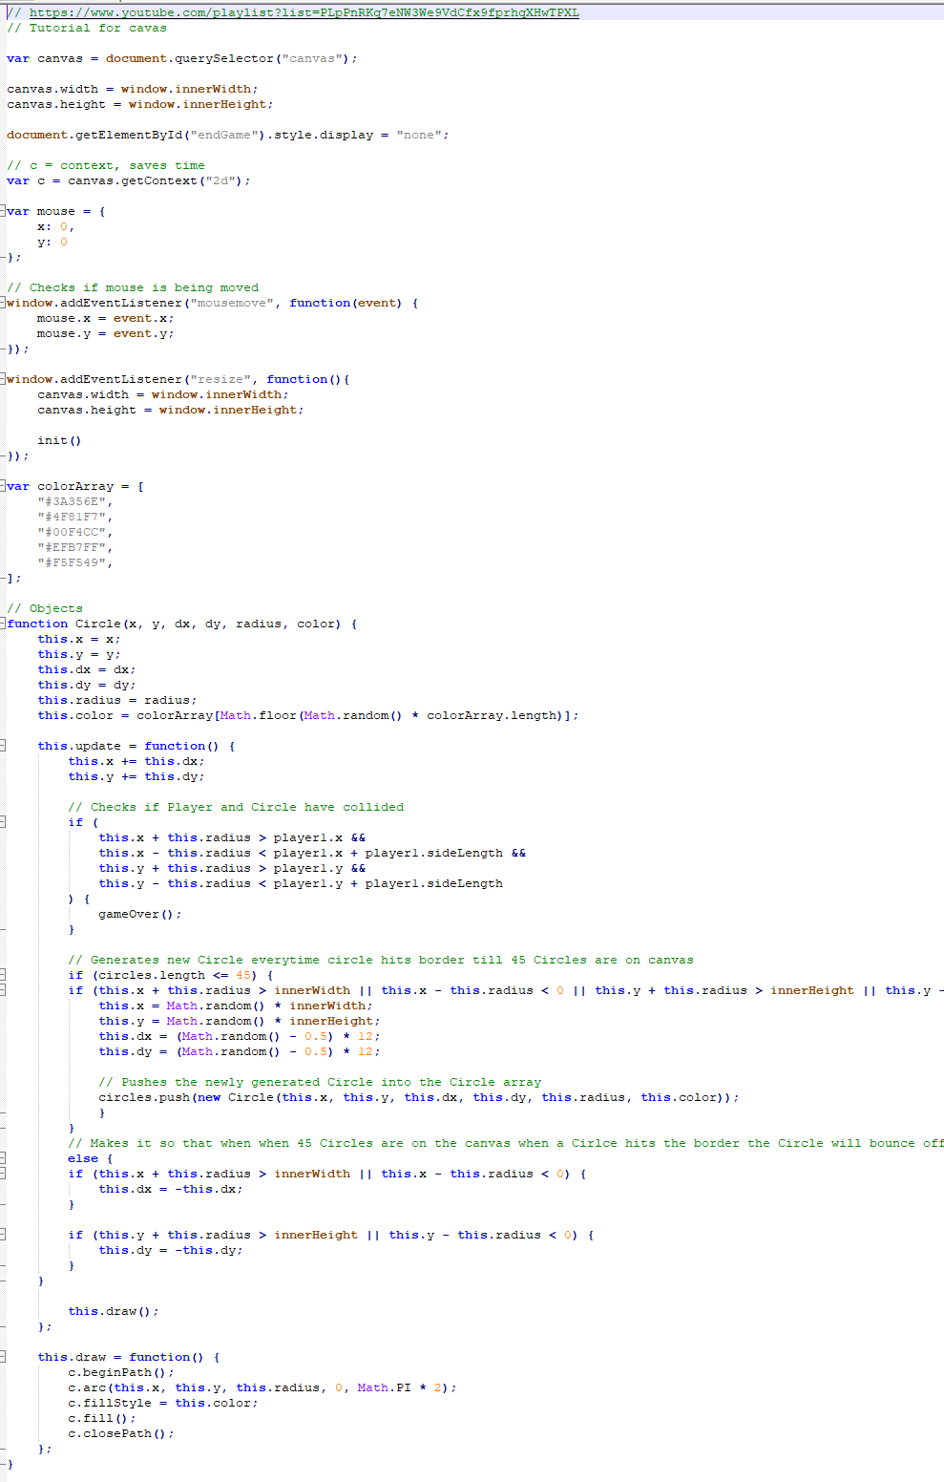

## Coding done by team member 3:

**HTML**

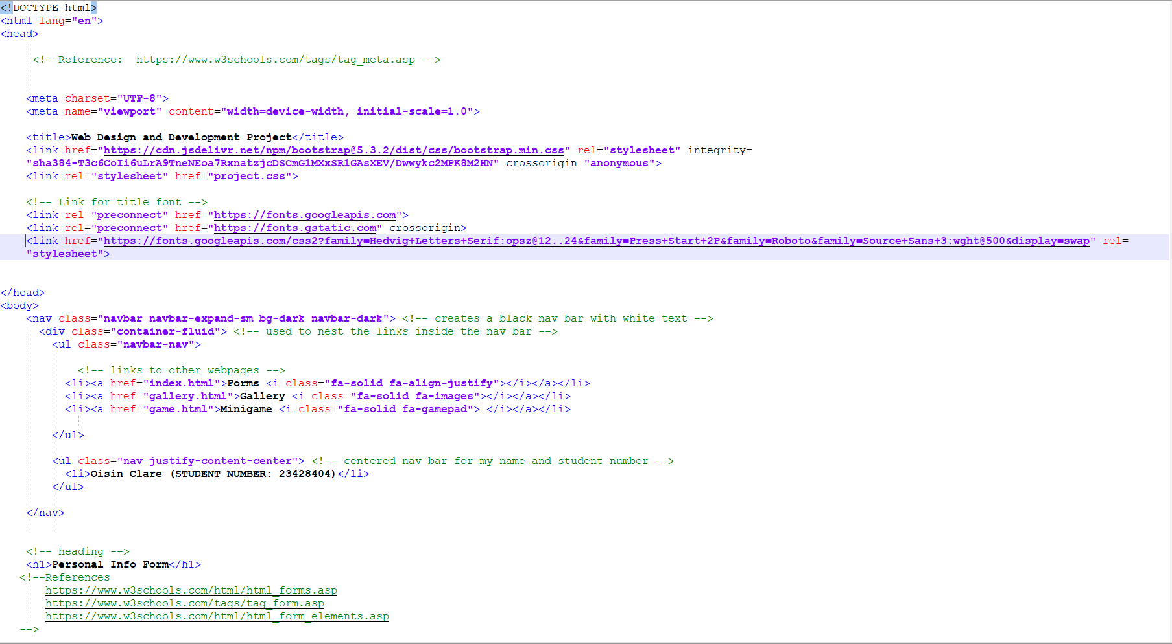

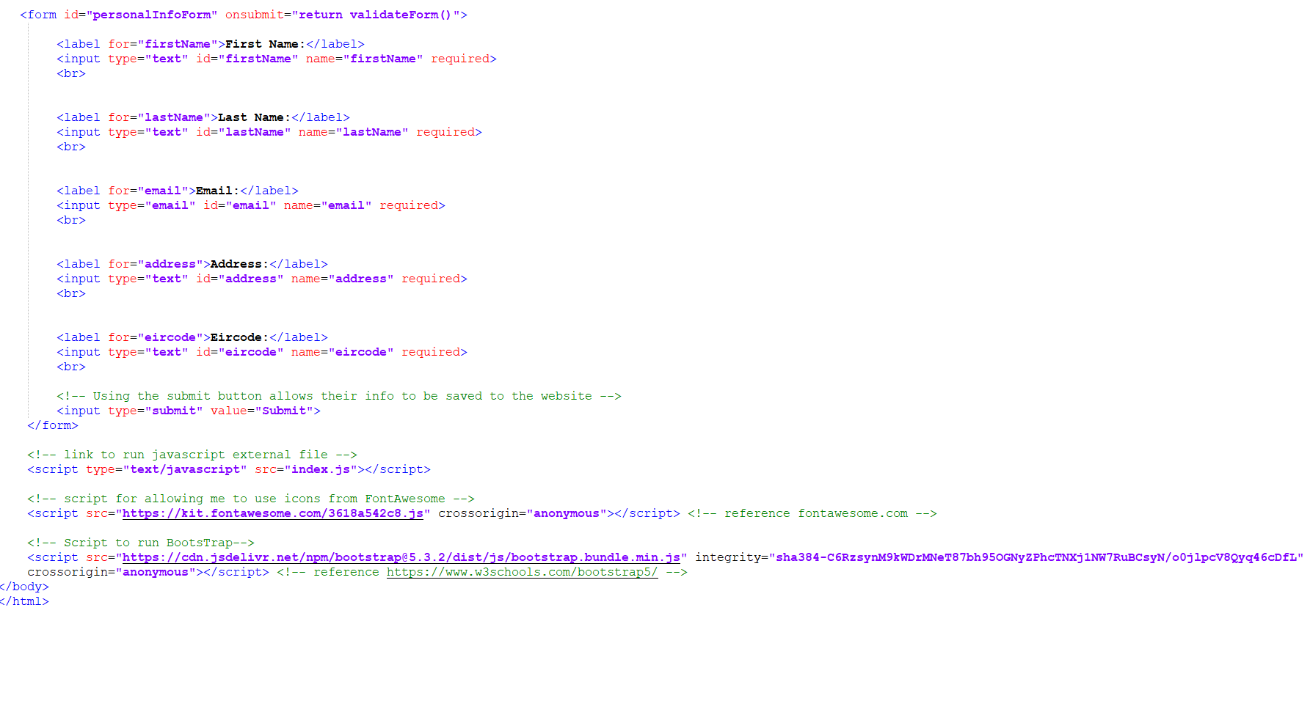

**JavaScript**

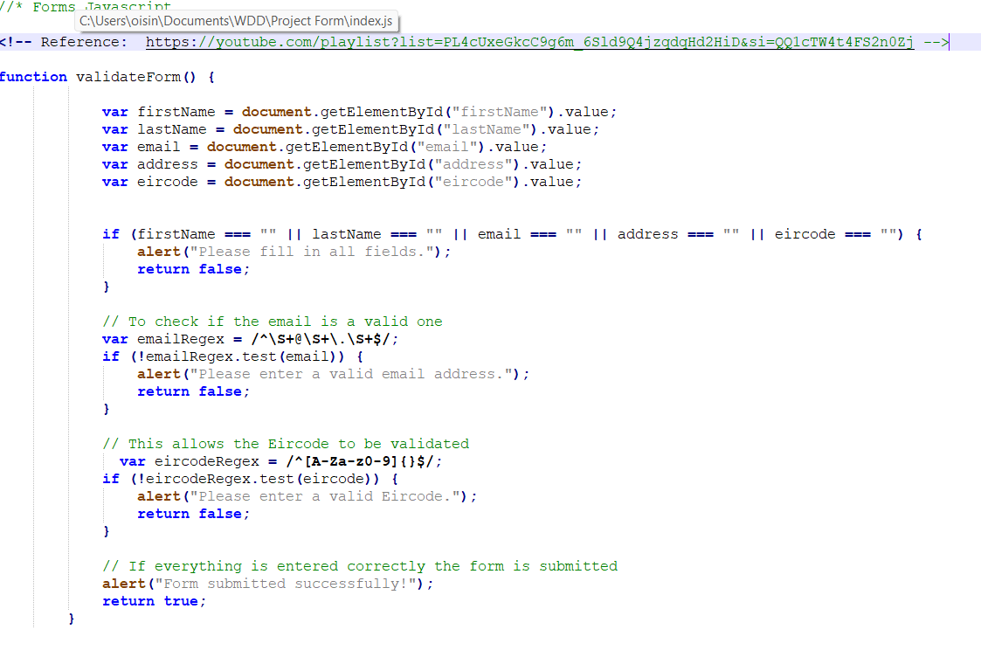

**CSS**

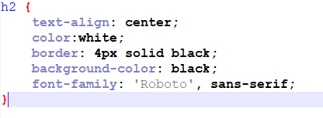

## Testing documented here:

**HTML validation**

**Index.html**

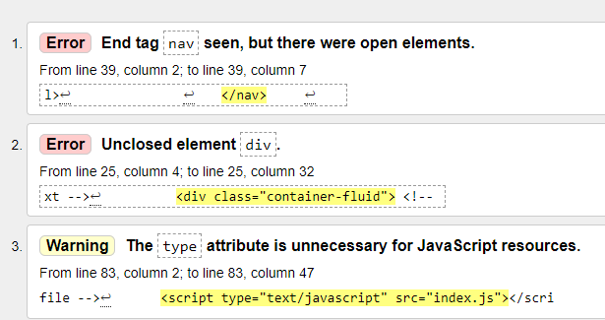

**Gallery.html**

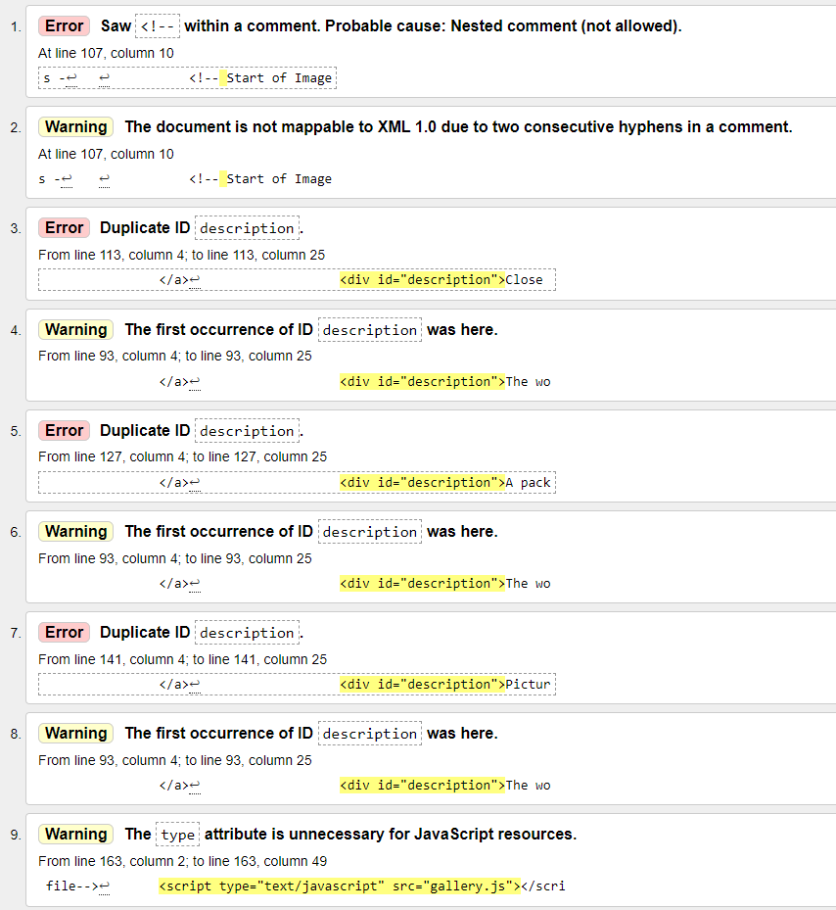

**Game.html**

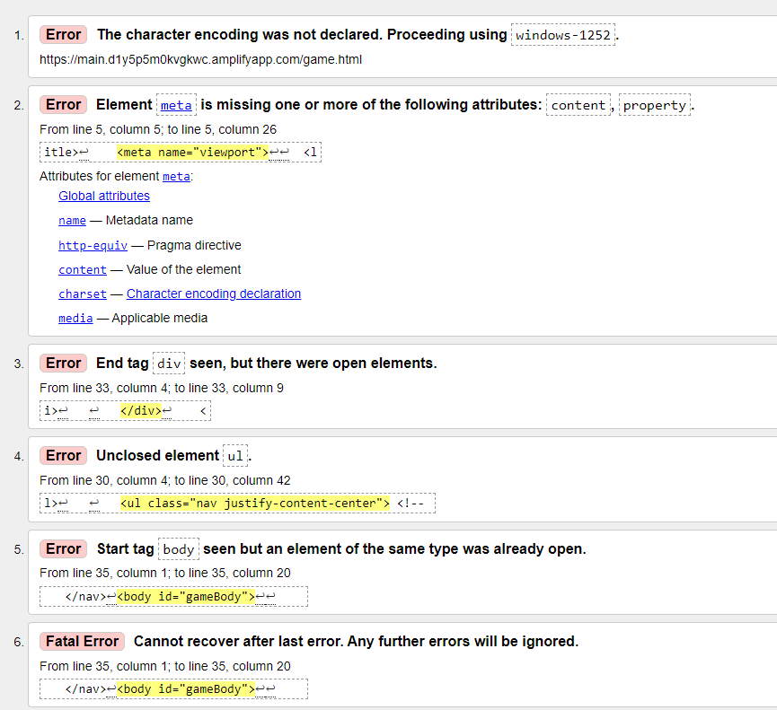

**Create a table to show testing of menu links and JS, responsiveness**

**Index.html**

|  |  |  |
| --- | --- | --- |
| Testing | Prediction / purpose | Result (Y/N + reason) |
| Navigation Bar | redirect to other pages from the website | Y |
| Entering info incorrectly | alert a fault | Y |
| Submit Button | Submit info | N, error with Eircode |
| Responsiveness | Readjust the page according to screen size | N |

**gallery.html**

|  |  |  |
| --- | --- | --- |
| Testing | Prediction / purpose | Result (Y/N + reason) |
| Navigation Bar | Redirect to other pages from the website | Y |
| Random fact button | Alert with random fact | Y |
| Image hover | Fade out and have text appear | Y |
| Press image | Open a bigger version in new tab | Y |
| Background button | Give a different background | Y |
| Responsiveness | Readjust the page according to screen size | Y |

**game.html**

|  |  |  |
| --- | --- | --- |
| Testing | Prediction / purpose | Result (Y/N + reason) |
| Navigation Bar | redirect to other pages from the website | Y |
| ‘Play’ button | Start the game | Y |
| Square hits circle (death) | End game and pop up with 2 buttons | Y |
| Play again | Reload page | Y |
| Home button | Redirect back to index.html | Y |
| Responsiveness | Readjust the page according to screen size | N |

**Deployment – speed test**

**Index.html**

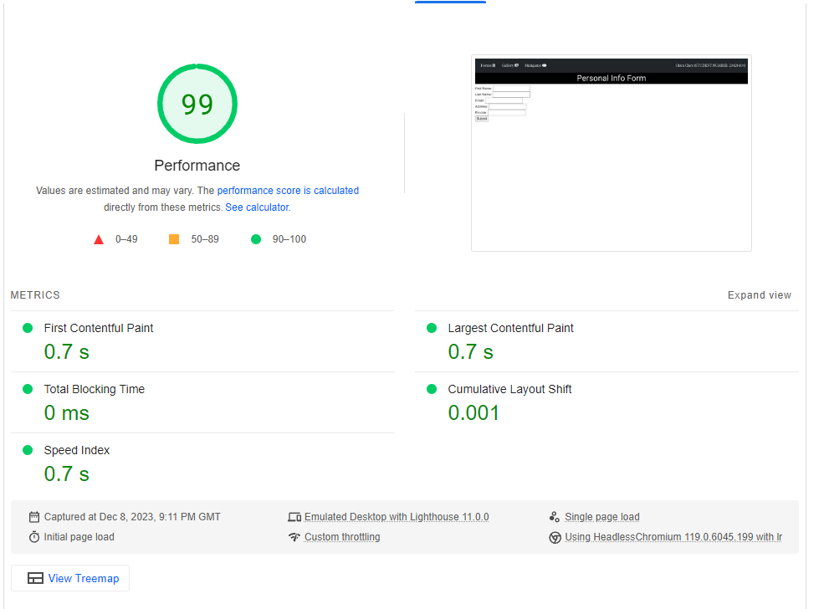

**Gallery.html**

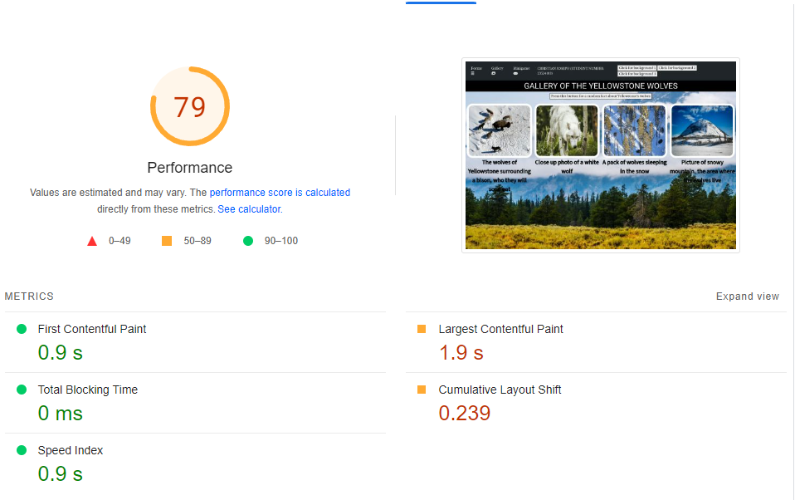

**Index.html**

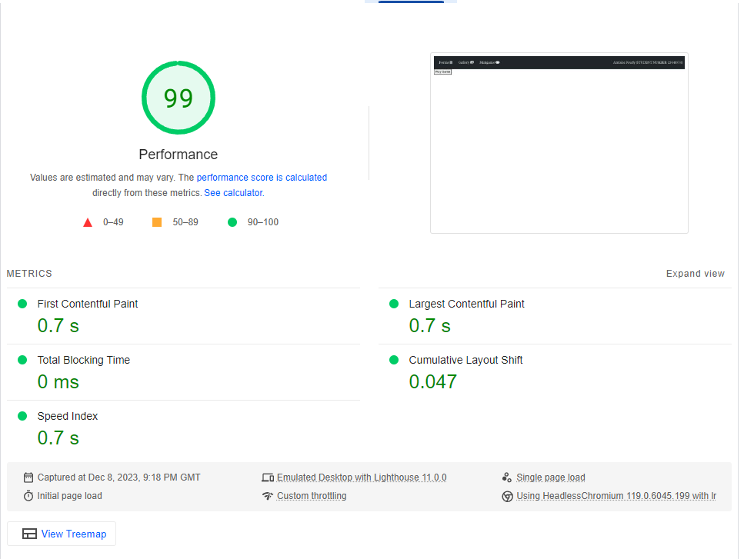

## Document the optimization of your images:

I ran all of the images through <https://tinypng.com/>, which optimised them and made them smaller so that they could load faster. I then ran the pictures through <https://www.img2go.com/resize-image>, so that I could put the gallery images to the same size, so they are equal.

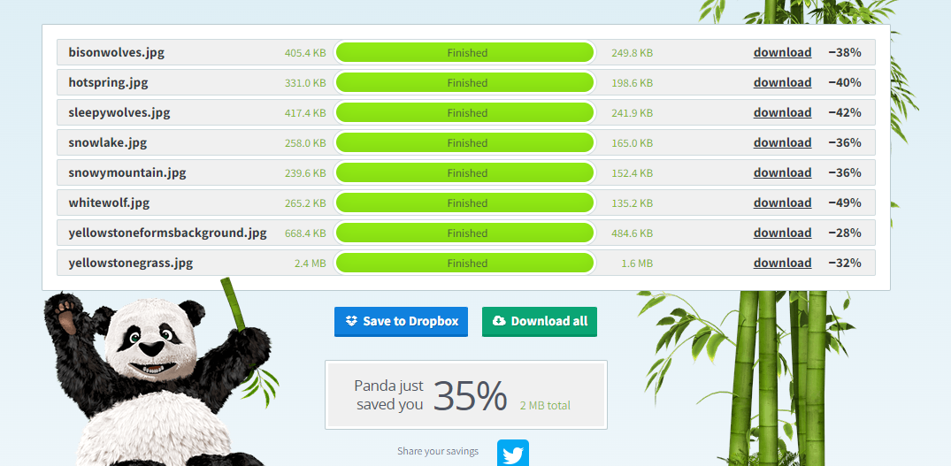

## Document the planning (excel/other)

